Q7 (labels (a), (b) and (c) should not be visible on the graph.)

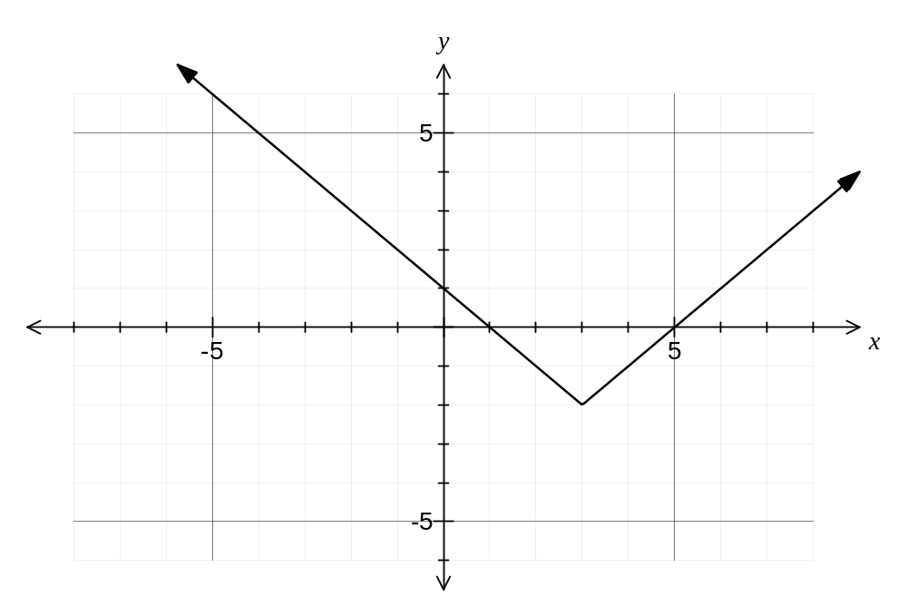

Q16b (label on the x-axis of the graph should read P/Po rather than just P)

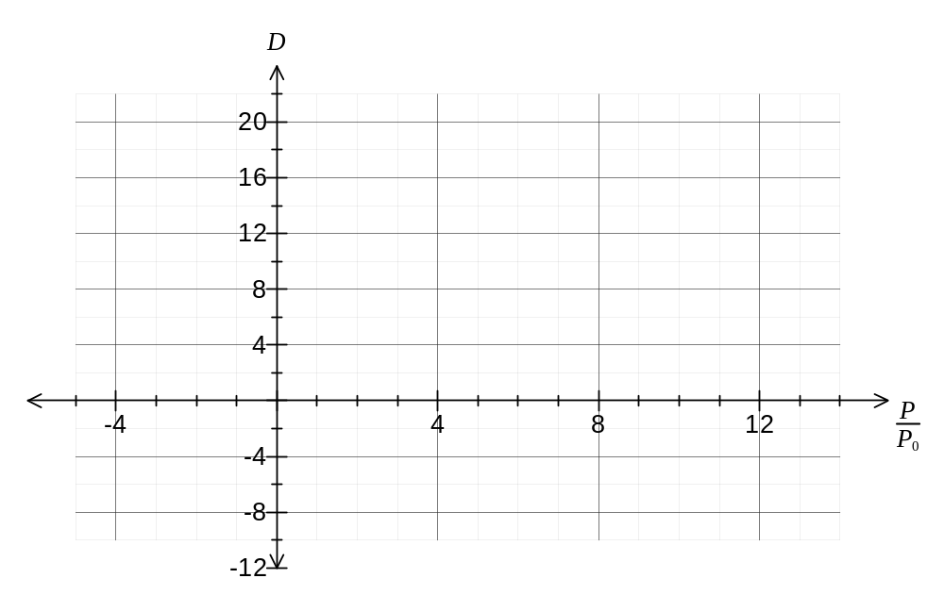

Q19c (zero vector should be bolded)

